The sections in the Functional Model
The EHR-S Functional Model is composed of a list of functions, known as the Function List, which is divided into seven sections:
- Overarching, OV. The Overarching Section contains Conformance Criteria that apply to all EHR Systems and consequently must be included in all EHR-S FM compliant profiles.
- Care Provision, CP. The Care Provision Section contains those functions and supporting Conformance Criteria that are required to provide direct care to a specific patient and enable hands-on delivery of healthcare. The functions are general and are not limited to a specific care setting and may be applied as part of an Electronic Health Record supporting healthcare offices, clinics, hospitals and specialty care centers.
- Care Provision Support, CPS. The Care Provision Support Section focuses on functions needed to enable the provision of care. This section is organized generally in alignment with Care Provision Section. For example, CP.4 (Manage Orders) is supported directly by CPS.4 (Support Orders).
- Population Health Support, POP. The Population Health Support Section focuses on those functions required of the EHR to support the prevention and control of disease among a group of people (as opposed to the direct care of a single patient. This section includes functions to support input to systems that perform medical research, promote public health, & improve the quality of care at a multi-patient level.
- Administrative Support, AS. The Administrative Support Section focuses on functions required in the EHR-S to enable the management of the clinical practice and to assist with the administrative and financial operations. This includes management of resources, workflow and communication with patients and providers as well as the management of non-clinical administrative information on patients and providers.
- Record Infrastructure, RI. The Record Infrastructure Section consists of functions common to EHR System record management, particularly those functions foundational to managing record lifecycle (origination, attestation, amendment, access/use, translation, transmittal/disclosure, receipt, de-identification, archive…) and record lifespan (persistence, indelibility, continuity, audit, encryption). RI functions are core and foundational to all other functions of the Model (CP, CPS, POP, AS).
- Trust Infrastructure, TI. The Trust Infrastructure Chapter consists of functions common to an EHR System infrastructure, particularly those functions foundational to system operations, security, efficiency and data integrity assurance, safeguards for privacy and confidentiality, and interoperability with other systems. TI functions are core and foundational to all other functions of the Model (CP, CPS, POP, AS and RI).
In the EHR-S FM Extension in enterprise Architect the representation of the list of sections is shown in figure 1.
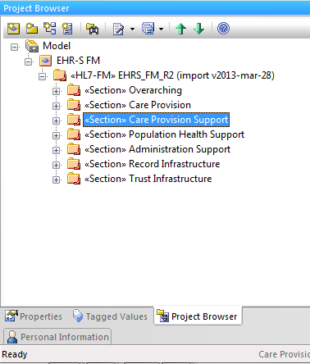
Figure 1: Function List Sections
Within the seven Sections of the Functional List the functions are grouped under header functions which each have one or more sub-functions in a hierarchical structure.

